Geogebra Lesson
Taylor Walton
Grades: 9 - 12

1. Using the 2nd box on the navigation bar, select Point tool (a), then create a point on your graph at (1, 1), Point A, and (1, 3), Point B (b).

(a) (b)

2. Using the 3rd box on the navigation bar, click Segment and create a segment between point A and point B by clicking on one of the points and then clicking on the other point.

3. Click on the 4th box on the navigation bar then select Perpendicular Line (a). Click on point A and segment a to create a perpendicular line to segment a (b).

(a) (b)

4. Next click on the 3rd box on the navigation bar and select the Segment tool. Then click on Point B and put the cursor near the point (4,1) and click. A segment will be created between (4,1) and Point B.

5. Then using the same segment tool, create a segment between point A and C.

6. Next click on the perpendicular line that we originally created (click somewhere outside of the triangle). Go to edit, then click Show/Hide Objects. Then you should be left with only your triangle.

7. Go to the 8th box on the navigation bar and select the Distance or Length tool (a). Then click on side AB, side BC, and side AC to calculate their lengths. Each side will be labeled with their length on your graph (b).

(a) (b)

8. Click on the 2nd box in the navigation bar and select Midpoint or Center tool. Then click on side AB, side BC, and Side AC in any order and the midpoints will be constructed.

9. Next go to the 6th box on the navigation bar and select the Circle with Center through Point tool (a). Click on Midpoint D then click on point A or B. Click on Midpoint E then click on point B or C (b). Click on Midpoint F then click on point A or C.

(a) (b)

10. In order to find the area of the circle we need the radius. So, using Input we are going to plug in (1/2) of each side of our triangle.
What letter represents this?
What letter represents this?
What letter represents this?

11. Now, to find the area of the semi-circles we are going to use the area of the full circles divided by 2. So, using Input we are going to square the letters that denote the radii of each semi-circle (derived from the side of our triangle), multiplied by π, all divided by 2.
What letter represents this?
What letter represents this?
What letter represents this?

12. Now we are going to calculate what the area of the semi-circles on the legs is by going to Input and plugging in their areas denoted by the letters in the algebra section, added together.

What is the area of j + k? What letter represents this?

What do you notice about the area of m, the combined area of the semi-circles on the legs, compared to the area of l, the area of the semi-circle on the hypotenuse?

Since m and l are equal, let’s plug in their area values from Step 11: m = l

Do you notice anything? Why do you think this is?

Hint: Think about how we find the length of any side in a right triangle. What did we do to the radii of the semi-circles in step 11?

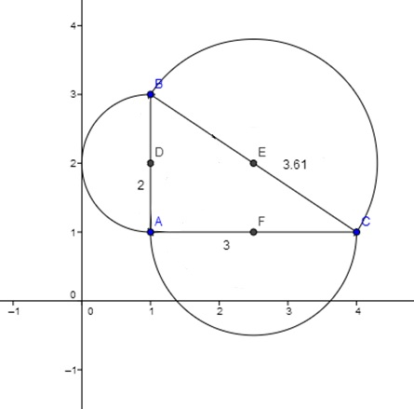
i
g

h

$$\frac{π{(g)}^{2}}{2}+ \frac{π{(h)}^{2}}{2}= \frac{π{(i)}^{2}}{2}$$

$$\frac{π}{2}(g^{2}+h^{2})= \frac{π}{2}(i^{2})$$

$$\frac{\frac{π}{2}(g^{2}+h^{2})}{\frac{π}{2}}= \frac{\frac{π}{2}(i^{2})}{\frac{π}{2}}$$

$$g^{2}+h^{2}= i^{2}$$

$$g^{2}+h^{2}= i^{2}$$

$$a^{2}+b^{2}= c^{2}$$

IT SHOWS THE PYTHAGOREAN THEOREM!

Challenge Problems
Try this same scenario with:
- Squares off each side of the right triangle

- Triangles off each side of the right triangle

- Rectangles off each side of the right triangle

Does every shape work?

